# AUTOMATED INVOICE GENERATOR

The project consists of 5 different blocks, 1 for the operation department and 4 for the Admin.

**SCOPE**: The main target is to minimise the interaction of the Operation Department on the final invoice, aiming to lower the chances of overlooks and mistakes, and to speed up the repetition of invoice creation and the creation of the PDF file, allowing the Admin to focus on the end results.

STRUCTURE: The project is composed of 5 visible sheets and 12 hidden sheets, containing the invoices for each country.

## VALUES

The reference taken from the inventory file. Its main purpose is to convert value from GBP to the different currencies for each invoice.

## MAP

It contains the mapped tables for Country Fulfilment Centres address and the mapped table for the US HS CODE, used to avoid long formulas affecting the cells.

It contains a dynamic, UNIQUE array that creates the base for the “Manufacturer Country” Tab in the invoice through a formula referring to the updating Pivot Table: =SUBSTITUTE(UNIQUE(TotInvPivot!B4:B1048576,FALSE,FALSE),0,"")

## SKU LIST

The main Sheet for the operations. It’s divided in two main blocks.

OPERATION DEPARTMENT BLOCK

* The Sku Table will be filled by the FBA person in charge. They will highlight the last item of each box in yellow.
* There’s a 5 steps process flow, to guide the user in entering the data.
  + CLEAR SKU LIST: clears formats and old skus.
  + CLEAN SKUS: removes country and fba extensions.
  + COUNTRY AND SHIPMENT CENTER: select relevant ones. The list is automatically updated with the mapped value.
  + GENERIC FIELDS: Shipment ID, FBA ID, DATE, WAYBILL NUMBER, NUMBER OF BOXES.
  + A reminder to highlight the last item in each box.
* Total Sku and Total Items for extra comparison and security.
* Address Tab to confirm the right shipment centre has been selected.

ADMIN BLOCK

Activated through a password (“Kanifa”).

It contains 4 main operations:

* **UPDATE INVENTORY**: needed in case of sku changes. It asks the user to select a datadump file which is created from the inventory file.

The process will be implemented during the weekly creation of the inventory backup on Tuesdays, leaving the file available for the Admin.

* **GENERATE ALL REPORTS**: the admin will change the HS CODE in the pivot table to match it with the current country. A prompt pops up as a reminder.

Once inserted the password, the system will generate 3 different invoices:

**Invoice** as the main one with the SKU and description classification.

**Total Invoice** for the metal + item type classification.

**Manual Packaging** for the box division. Extra sheets are created according to the number of boxes entered.

* **GENERATE PDF:** Download the PDF in the selected folder. Sheets are printed by fitting all columns in one page, avoiding overflows.
* **EXPORT SKU LIST**: generates a text file and updates it with all the skus from current shipment. Used at the end of the month for the Amberta and Transterling stock transfers.

## TOT INV PIVOT

It contains the main Pivot Table for the Total Invoice.

The table is updated automatically. The HS Code needs to be switched before generating the reports. The country reminds the used of the value to use.

## QUANTITIES AND INVOICE

It contains the imported Inventory from the “Update Inventory” button. Only the first 7 columns are imported from the data dump file created from the inventory. The other columns contain formulas to create the needed data for the Pivot Table and the Invoices.

## Country invoices

Automatically updated and hidden from view when not needed. They can be changed by the Admin before the final printing.

## A LOOK AT THE CODE

The VBA code is based on 9 modules.

**ADMIN**: controls the automated functions to disable and enable to speed up the processing times.

They are switched on at the start of the main functions to optimise processing times by **disabling** the speed-consuming Application basic functions.

They will be reactivated once the process has gone through.

**TIME FOR PROCESS TO COMPLETE AND CREATE FULL, READY-TO-USE INVOICES : 10 seconds.**

**BASIC INVOICE:** it creates the first invoice model. It works based on a few processes:

* It establishes the country name, finding the reference in the Name Range.   
  The ranges are used to establish the working space for the SKUs to be inserted. All countries have the same named ranges, the only variation is the country prefix to make it dynamic:

USGoods, CAGoods, EUGoods, etc etc.

They mark the delimiters of the working area.

This slice erases extra rows if not needed, creating a clean sheet.

The next section inserts the extra rows needed, with the proper format, and call for another subprocedure.



* After creating a data dump sheet to temporarily store the results, the sub-procedure searches for the relative column in the Inventory Sheet, copying the matching result and creating the data to be transferred. Then, the columns get copied pasted on the relative working area defined previously.

**TOTAL INVOICE:** It creates the invoice model for the main metal type + items groups.

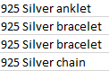It makes use of an existing pivot table, which updates when the user inserts new skus or there are changes at the inventory level. It doesn’t directly depend on the user input.   
 The Admin needs to change the HS Code to match the current country. A warning reminds them of this step.

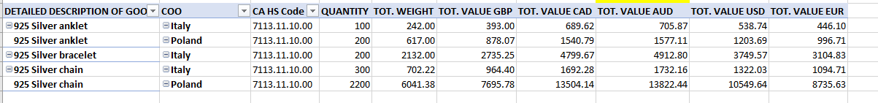

The code works as the previous sub-procedure in its core functionality:

* Clean the working area.
* Find the related columns, saving them in the datadump file.

Copy the created blueprint and paste it in the invoice.

**PACKING LIST:** It updates the current packing list invoice and creates new according to the **boxes number.**

The core of the code is the Do while Loop.

The loop will run until it matches the final number of boxes, creating a new copied worksheet and adding a “Box” + current box number to the worksheet name.

It will make use of a combination of inputs: the boxes number and the last item per box, highlighted in standard yellow by the Operation Department at the time of entering their data.

Then, it will find the matching columns and creates the datadump as the previous sub-procedures.

**GENERATE REPORTS:** It’s the sub-procedure containing all the public, shared variables among the modules and the final call for all procedures to run.

It will remind the Admin about the need of changing HS code in the Pivot Table. then it will ask for a password and activate the procedures if the password is correct.

The correct invoices per country will be showed and updated.



**PRINTING:** It allows the Admin to choose the folders to save the invoices in and prints a formatted PDF copy of all the necessary documents.   
 The page layout is taken care of at point of creation, needing no input from the user. If necessary, the user can still create manual copies of their pdf if changes are needed.

**SAVE TEXT:** It will store and append the SKU list to a monthly file in the Accounting’s folder, allowing the Financial department to keep track of all the transfer of stock from Amberta to Transterling.

It will cut considerably the times, as this procedure was previously done by manually researching the quantities.

Once saved, at the end of the month, the data can be saved in a invoice though another automated spreadsheet:

**STOCK_TRANSFER_MONTHLY.**

### TROUBLESHOOTER

**The packaging List doesn’t create the right number of boxes.**

Please make sure the correct number of boxes has been inserted and that the last items for each box have been correctly highlighted. The colour used for the boxes is standard yellow.

**The invoice doesn’t get filled properly.**

Please make sure you selected the right **HS CODE IN THE PIVOT TABLE.** That is a manual update required due to the volatile function of the different codes by country.

**Some fields like date and reference number are empty.**

Please make sure the fields are entered correctly in the main page. If yes, then please check the formula inside the relative cells on the invoices to see if the range still matches.

**I want to change some settings on the PDF.**

You can still manually print any generated invoice by using the standard method in the “Save As” and “Print” functions.

**The fulfilment centre address doesn’t show up.**

Please inform the developer if a new fulfilment centre has appeared. The map values need to be updated. If needed, the address can be manually pasted in the invoices as a temporary solution.

Otherwise, add the FULFILMENT CENTRE number and the relative address in the Map Tab, as shown below:

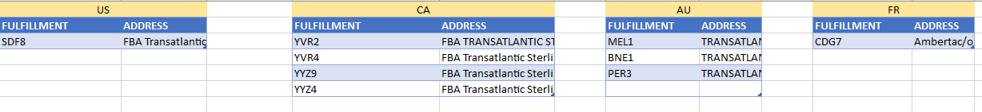

Choose the relative country and update the table.

**The right country isn’t showing up.**

Please make sure you selected the right country in the Settings on the Sku List page.